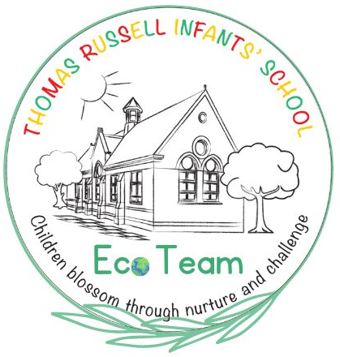
Eco Team News
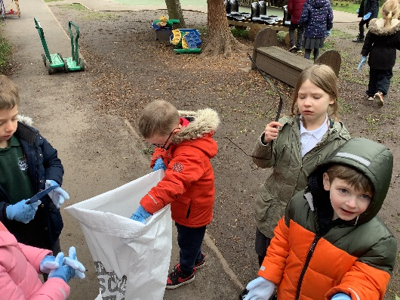
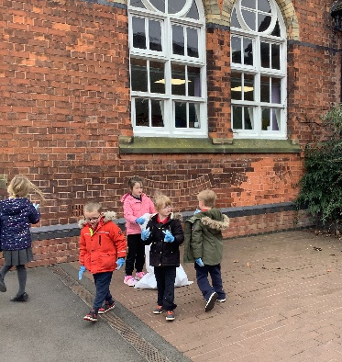
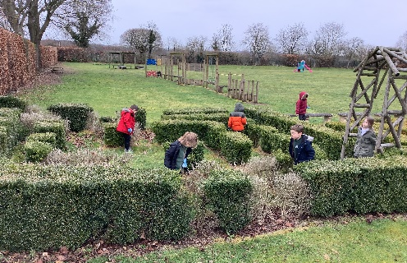
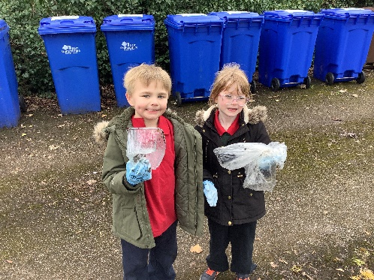
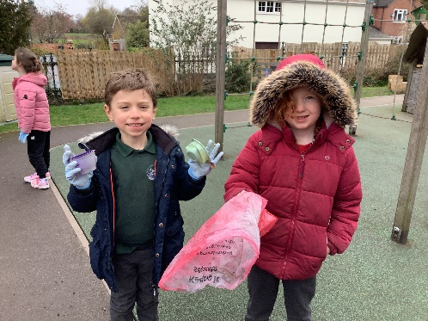
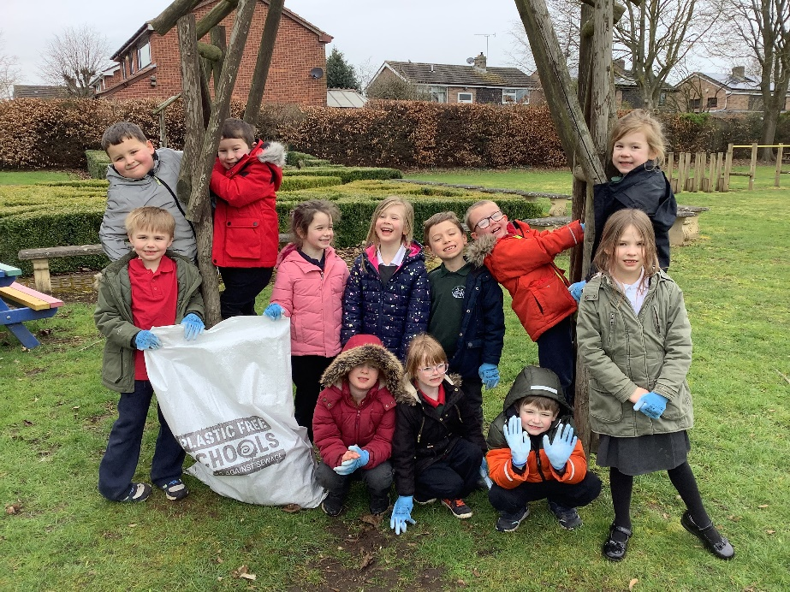
This week, our Eco Warriors participated in the Plastic Free Schools ‘Trash Mob’. We collected all of the litter from around our school grounds and bagged it up. Our school was already very tidy, so we only half-filled one bag in total! This is one of the objectives that we are completing for the Plastic Free Schools award.

