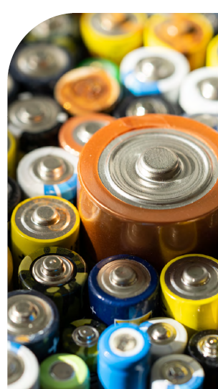
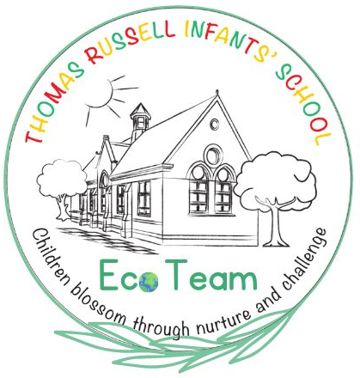
Eco Team News
We now have a battery recycling point in school. The box is located inside in the main entrance. Don’t forget that we still recycle ink cartridges too.
Batteries cannot be disposed of with normal household waste as they contain harmful heavy metals that are toxic to the environment and human health.
- Car batteries, industrial batteries and batteries with connecting wires cannot be accepted at our recycling point.
- Damaged or leaking batteries cannot be accepted.
- Where possible, lithium batteries should have their terminals taped over.
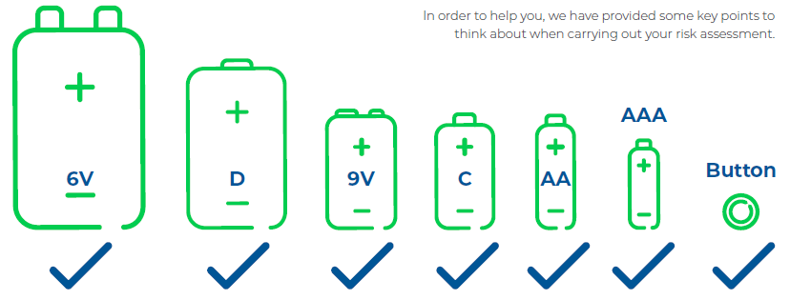
We accept the following batteries:

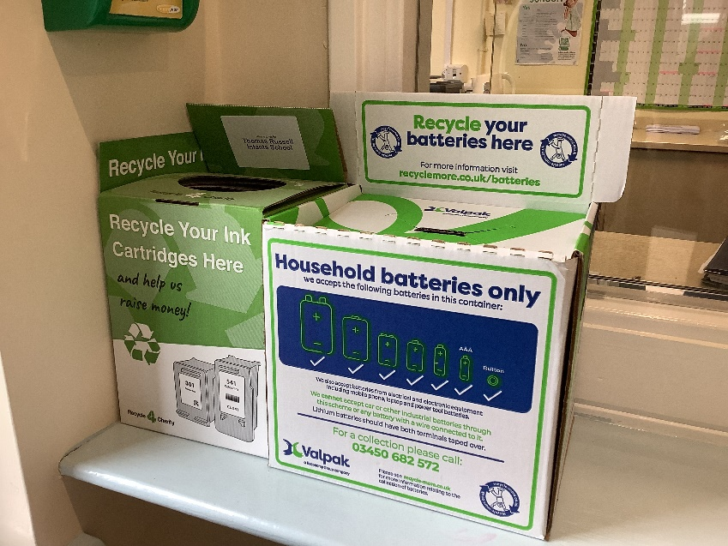
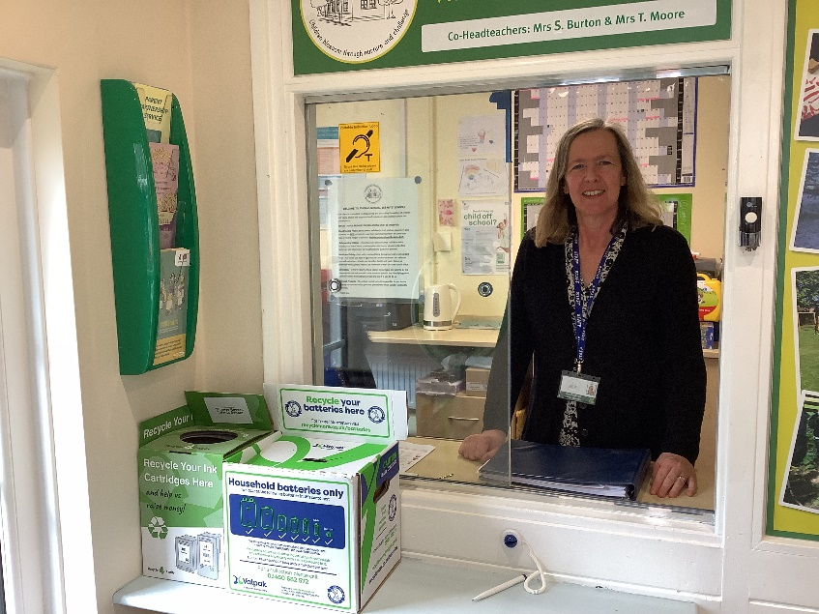
Our battery and ink cartridge recycling points:

